Name:M.Swathy

College:Akshaya College Of Engineering and Technology

Company:Enoah i Solution

Date:21-05-2021

Project Title:CafeAPI

**CafeAPI**

* INTRODUCTION:

This project is mainly about creating web API for Café and types of Food.Here I used SQL database for creating tables to store record of food and types.The language used for creating and testing is C#.Once the database is created the records are been accessed in web by coding in Visual Studio,which is a platform for writing C# code.The main aim is to display the records of food in web using API.The CRUD operation is also done to modify the records of food each time.Atlast the code is tested in visual studio code.

* DATABASE:

1.Entities:

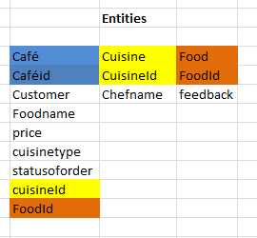

2.Tables created:Cafe,Cuisine,Food

Primary key:CafeId(Café table),CuisineId(Cuisine table),FoodId(Food table)

Foreign key:CuisineId,FoodId(Café table)

1.Café table:

create table Cafe(CafeId int not null primary key,CuisineId int,FoodId int,CustomerName varchar(20),FoodName varchar(20),CuisineType varchar(20),Price decimal(4,2),Status varchar(10));

select * from Cafe

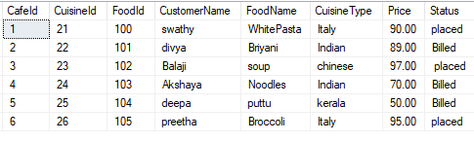

2.Cuisine table:

create table Cuisine(CuisineId int not null primary key,ChefName varchar(20));

select * from Cuisine

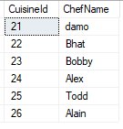

3.Food table:

create table Food(FoodId int not null primary key,Feedback varchar(20));

select * from Food

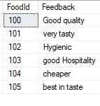

* CAFÉAPI:

Creation of API includes creating,inserting,deleting and updating values in a table.This is done using Visual Studio Code.This can be checked in postman by performing Get,Post,Put,Delete.Postman is a good platform for API development.

* AUTHENTICATION WITH LOGIN METHOD:

Authentication is the process of identifying users that request access to a system, network, or device. Access control often determines user identity according to credentials like username and password. Other authentication technologies like biometrics and authentication apps are also used to authenticate user identity.

1.Login Test and Login Fail Test:

Method:Logintest

Description:logins with username and password

Parameter:username and password as parameter is passed

Returns:login success

2. Method:Login fail test

Description:login fails due to wrong username and password

Parameter:username and password parameter is passed

Returns:Login failed

* CRUD:

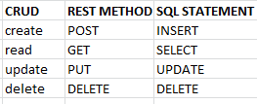

1. Method:Get Café

Description:Gets the CafeId

Parameter:CafeId

Returns:Café object C

2. Method:GetallCafe

Description:Gets all the café details

Parameter:NULL

Returns:café details

3. Method:Insert cafe

Description:inserts new details in Café table

Parameter:new café detail

Returns:new CafeId

4. Method: Update cafe

Description: Updates details in Café table

Parameter: new café detail

Returns: numofRows

5. Method: Delete cafe

Description: Deletes details in Café table

Parameter: CafeId

Returns: numofRows

* TESTING:

**Testing** is the process of executing a program with the aim of finding errors. To make our software perform well it should be error-free. If **testing** is done successfully it will remove all the errors from the software.

|  |  |  |  |  |  |
| --- | --- | --- | --- | --- | --- |
| Test Case Number | Step Number | Description | Return Value | Expected | Actual |
|  |  |  |  |  |  |
| ST- 001 | 1 | Insert Café | Student Id | >0 | >0 |
|  | 2 | Get Cafe for inserted StudentId | Inserted Student | NOT NULL Customername = Inserted customername  Foodname = Inserted FoodName  CuisineType = Inserted CuisineType | NOT NULL Customername = Inserted customername  Foodname = Inserted FoodName  CuisineType = Inserted CuisineType |
|  | 3 | Update Cafe | Number of Rows | = 1 | = 1 |
|  | 4 | Get Cafe for updated Cafe | Updated Student | NOT NULL Name = Updated CustomerName  FoodName= Updated FoodName  CuisineType = Updated CuisineType | NOT NULL Name = Updated CustomerName  FoodName= Updated FoodName  CuisineType = Updated CuisineType |
|  | 5 | Delete Cafe | Has Been Deleted | True | True |
|  | 6 | Get Deleted Café | Café | NULL | NULL |

Types Of Testing:

1.Unit testing

2.Integration testing

3.Regression testing

4.Alpha testing

5.Beta testing

Here we used Unit testing

* UNIT TESTING:

It focuses on the smallest unit of software design. In this, we test an individual unit or group of interrelated units. It is often done by the programmer by using sample input and observing its corresponding outputs.

Example:

a) In a program we are checking if loop, method or function is working fine

b) Misunderstood or incorrect, arithmetic precedence.

c) Incorrect initialization

1.Method: GetCafesTest

Description: Gets the tests for testing values in the Code

Parameter: NULL

Returns: Cafes

2.Method: GetCafeTest

Description: Gets the test for testing values in the Code

Parameter: CafeId

Returns: CustomerName

3. .Method: InsertCafeTest

Description: inserts values for testing for checking whether the values are inserted

Parameter: NULL

Returns: Inserted Details

4. Method: UpdateCafeTest

Description: checks whether values are updated

Parameter: NULL

Returns: updatedCafe

5. .Method: DeleteCafeTest

Description: check how many rows are deleted

Parameter: CafeId

Returns: numOfRows

* API testing Using NUNIT:

1.Method:CreateCafeAsync

Parameter:newCafe

Returns:Café

2.Method:GetCafeAsync

Parameter:Id

Returns:Café

3.Method:Get Cafes Async

Parameter:NULL

Returns:Cafés

4.Method:update Café Async

Parameter:update Cafe

Return:Café data

5.Method:Delete CafeAsync

Parameter:Id

returns:num of rows